Molecular Biology for

Computer Scientists

Notes

All living things are made of cells

Cell 🡪 membrane-enclosed sacks of chemicals carrying out finely tuned sequences of reactions called metabolic pathways

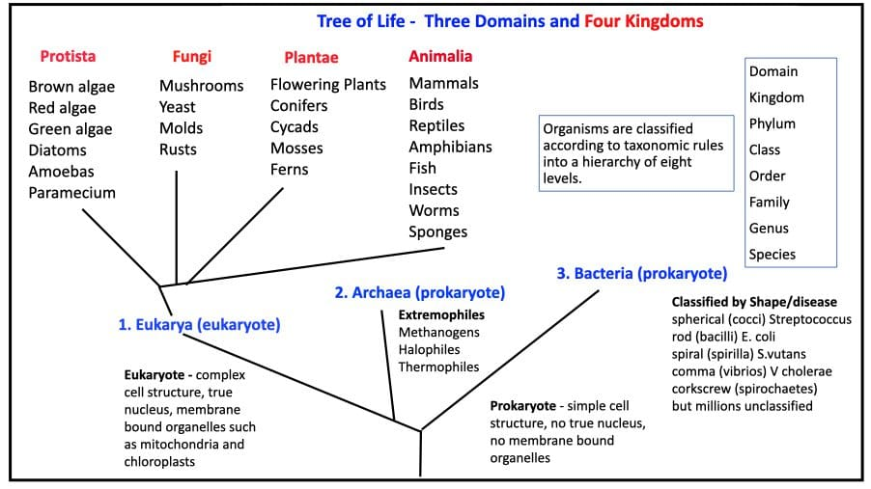

Eukarya

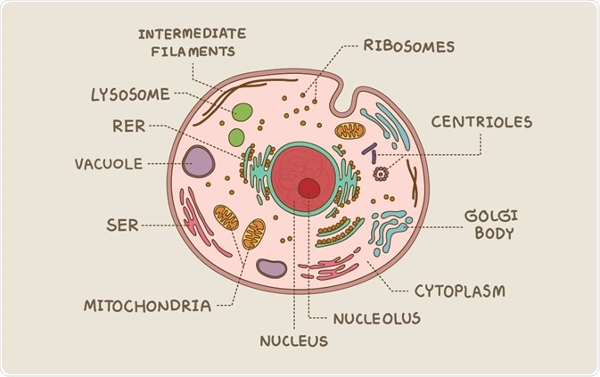

* Contains nucleus to hold genetic information
* Multi-chromosomal
* Contains organelles like
  + Mitochondria – powerhouse of the cell
  + Chloroplast – capture energy from sunlight

Fungi vs Green Plants

* Fungi do not photosynthesize

Prokarya

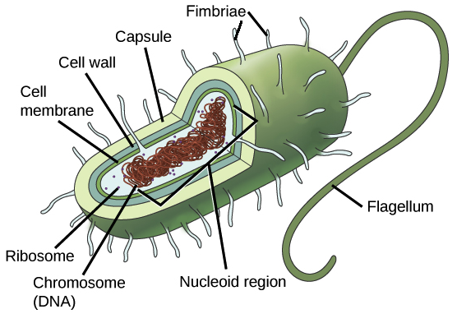

* No nucleus so genetic information in cytoplasm
* Single-chromosome
* Unicellular organism

Archaea

* Prokaryotic organism that lives in superheated Sulphur vents in the deep sea
* Do not require oxygen

Viruses

* Zombies
* Parasites – Relies on the biochemical machinery of the host organism to survive i.e. parasitic relationship
* Virus inject their genetic information (often stored in their RNA) into the living organisms. When this organism cells multiply then the virus also replicates.

Symbiotic relationship

* Bacteria in our guts
* We eat food. Some of it digested. The remaining undigested food (like starch) is digested by the bacteria in our guts
* The opposite of parasitic relationship

Phage Medicine

* Utilizes bacteriophages (viruses that infect and kill bacteria) to treat bacterial infections
* Infect bacteria with virus to counter other bacteria

Multicellular organisms

Why

* Multicellular organisms can have cells that are far apart in distance. These cells can exchange matter, energy or information for their mutual benefit
* For example, in plants, cells in the root of the plant supply energy to the cells in the leaves and vice versa.

Property

* All multicellular organisms begin from a single fertilized egg called a zygote.
* Multicellular organisms separate cells for reproduction called germ cells and other tasks called somatic cells
* For example, sperm and eggs are germ cells

Somatic Cells vs Germ Cells

* Somatic cells undergo differentiation where they specialize for a particular task.
* For example, skin cells, nerve cells, blood cells, tissue and organ cells etc.

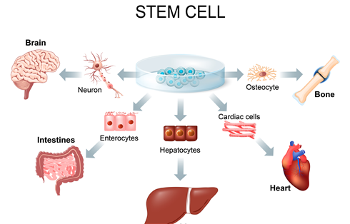

* Somatic cells are diploid, meaning they contain two complete sets of chromosomes (one maternal and one paternal) while Mature germ cells (gametes) are haploid, containing a single set of chromosomes.

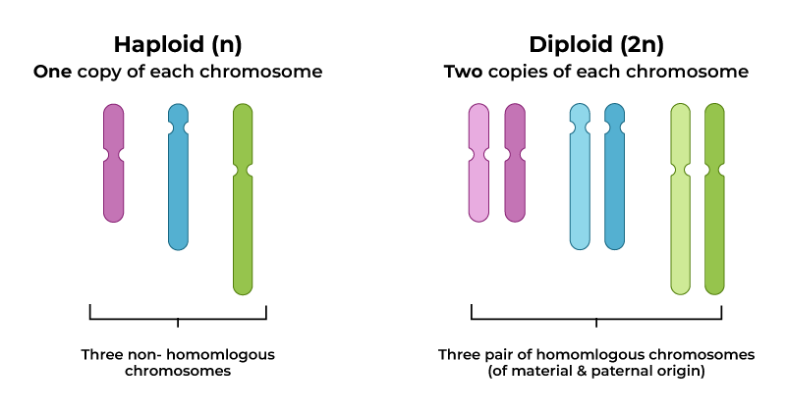

* Somatic cells undergo mitosis while germ cells under meiosis

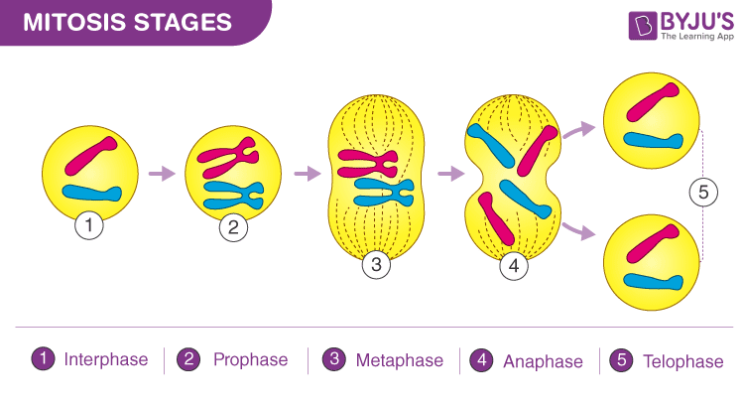

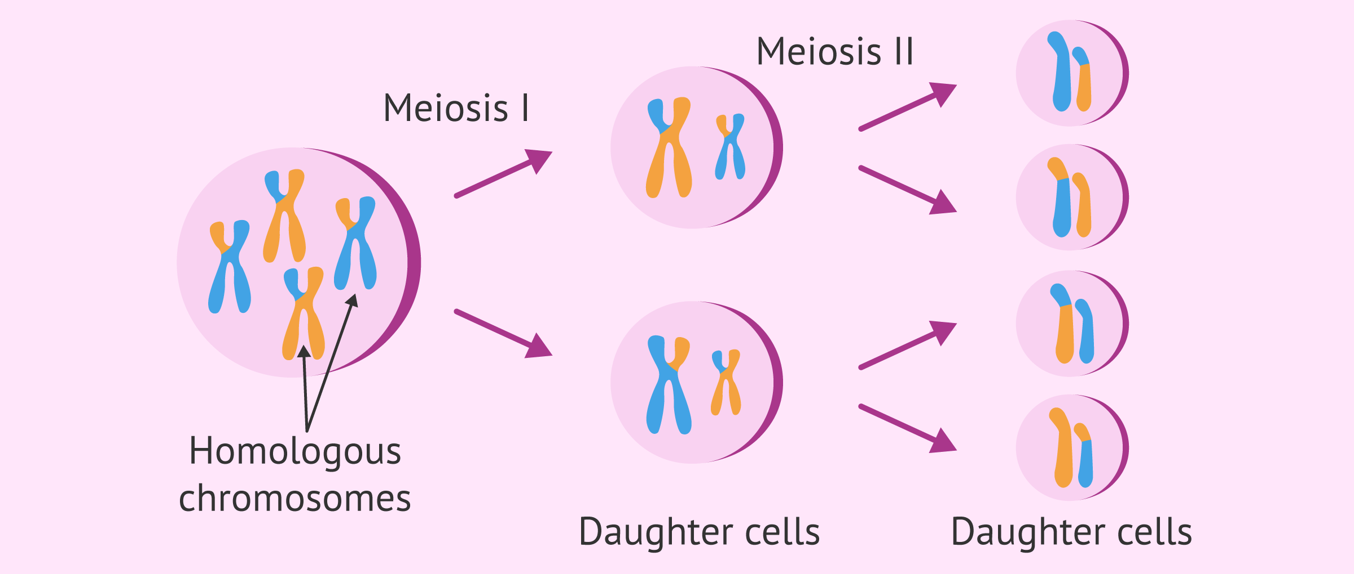

* Variation in somatic cells does not affect descendants while variation in germ cells does affect